MILITARY INSTITUTE OF SCIENCE & TECHNOLOGY

Department of Electrical Electronic and Communication Engineering

COURSE NO. : EECE 304 Digital Electronics Laboratory


Project Report
Dual Axis Solar Tracker Using Logic Gates as a Controller

Group-5
SL | Name | ID
1 | Md Zain Akhter Bin Helal | 202216030
2 | Raisul Islam Ratul | 202216049
3 | Mahmud Hasan Asif | 202216203
4 | Md Sadman A Rahman | 202216053
5 | Allama Rejuan | 202116007
6 | Md. Salman Rashid Himel | 202116169
7 | Shazia Afrin Anika | 202016083



Table of Contents
Serial no | Content | Page no
1 | Abstract | 1
2 | Objectives | 1
3 | Introduction | 1
4 | Relevant Theory | 2
5 | Literature Review | 3
6 | Working Principle and Methodology | 4-5
7 | System Design  - Components  - Block Diagram  - Circuit Design | 6-12
8 | Software  - Proetus (Simulation)  - Quartus II (Verilog Code) | 13-15
9 | Results and Discussion | 15
10 | Advantages and Limitations | 19
11 | Real Life Implication | 19
12 | Future Scope | 20
13 | Conclusion | 21
14 | Reference | 21

Abstract
This project deals with dual-axis solar tracking to collect maximum rays using LDRs. It resolves the problem by providing an arrangement for a solar panel to track the movement of the sun on both axes. With the increase of scarcity of nonrenewable resources, people are trying to identify alternate sources of energy. From all available renewable resources, solar energy is relatively easy to convert to electrical energy. The use of solar panels to convert the sun’s energy to electrical energy is very popular. But due to the movement of the Sun from east to west the fixed solar panels may not be able to generate ideal energy. Hence single-axis solar tracking systems were introduced aiming to generate ideal energy. But even single-axis solar tracking has been analyzed and results show that it can track sun rays on only one axis (either north-south or east-west). Hence a prototype is constructed more efficiently to track maximum sun rays in both the axes (both north-south and east-west). It is a low-cost system that provides better efficiency. Here the analog signals are analyzed and controlled by basic electrical component. This automatic system is completely done by logical elements. The energy obtained from the sun is collected using a solar panel by arranging four LDRs. The amount of energy obtained and positions at two LDRs on the same axis are compared and analyzed to decide the movement of the dc motors which moves the panel to the direction where more energy is available. A comparative analysis shows that a dual axis solar tracker is 10-15% more effective than a stationary solar panel and about 8-10% more effective than a single axis solar tracker.

Keywords—solar tracking; single axis; dual axis; light depending resistor (LDR),

Objectives
The objectives of the proposed work are as follows

- To design a dual solar tracking system that can collect maximum amount of sunlight on the solar panel.
- To optimize and increase the efficiency of output than existing system.
- To analyze the performance of various solar tracking and find out the best efficient way to maximize the output.
- To learn the actual use of different basic electrical elements and logic gates.

Introduction
Energy is a crucial driver for global development, and with the rising population, the demand for energy is increasing rapidly. Fossil fuels like oil and coal are the primary energy sources today, but they are limited and contribute heavily to pollution and global warming. To move toward sustainable energy, there is a growing shift to renewable sources like solar, wind, and hydropower. Among these, solar energy stands out as a vast, inexhaustible resource. However, to fully harness solar power, efficient methods like solar tracking systems are necessary to capture the sun's energy more effectively.
Solar tracking systems ensure that solar panels maintain an optimal angle to the sun throughout the day, increasing energy capture. Dual-axis trackers, which move both horizontally and vertically, are particularly effective, capable of increasing solar energy output by up to 45% compared to fixed systems. They track the sun’s movement more accurately, making them ideal for regions with significant seasonal changes in sunlight. This project focuses on developing a dual-axis solar tracker using basic logic gates instead of more complex and expensive microcontroller-based systems.
The use of logic gates in this project simplifies the design, offering a cost-effective and reliable control system. Logic gates process input signals from Light Dependent Resistors (LDRs) and adjust the solar panel’s position accordingly, ensuring real-time tracking of the sun. By utilizing this straightforward digital approach, the system achieves efficient solar tracking while minimizing costs. The dual-axis solar tracker demonstrates the potential of simple logic gate-based systems to enhance renewable energy collection, contributing to a cleaner and more sustainable energy future.

Relevant Theory

Solar Power
Solar power is energy derived from the sun's radiation, which is captured and converted into electricity or heat. It is one of the most abundant and renewable energy sources available. Solar energy can be harnessed using photovoltaic (PV) cells, which convert sunlight directly into electricity through the photovoltaic effect. When sunlight hits the PV cells, it excites electrons, generating an electric current. The energy produced is clean, with no greenhouse gas emissions, making it a key component in efforts to reduce reliance on fossil fuels and combat climate change. Solar power can be used in residential, commercial, and industrial applications, ranging from small-scale solar panels to large solar farms.

Solar Tracker
A solar tracker is a device that automatically adjusts the orientation of a solar panel so that it remains aligned with the sun's rays throughout the day. By tracking the sun’s movement, solar trackers ensure that the panels are positioned at the optimal angle to maximize energy production. There are two main types of solar trackers:
- Single-axis trackers: These trackers move either horizontally or vertically to follow the sun’s movement along one axis (east to west or north to south).
- Dual-axis trackers: These systems adjust in both horizontal and vertical directions, allowing the panels to follow the sun’s movement across the sky throughout the day and seasons.
Dual-axis trackers are particularly efficient because they can track both the daily and seasonal movements of the sun, resulting in increased energy output compared to static panels.

Logic Gates
Logic gates are the fundamental building blocks of digital circuits, used to perform simple logical operations on one or more binary inputs to produce a single binary output. In the context of electronics, binary signals have two states: high (1) and low (0). Logic gates process these inputs according to specific rules to produce outputs that control other components in the system.
In the context of a solar tracking system, logic gates can be used to process input signals from Light Dependent Resistors (LDRs) that detect sunlight. Based on the logic gate outputs, motors are activated to adjust the position of the solar panel, keeping it aligned with the sun. The use of logic gates offers a simple, cost-effective solution for controlling solar trackers without the need for complex microcontroller programming.

Literature Review

Previous Work in Solar Trackers (Single-Axis and Dual-Axis)
Solar tracking systems have been extensively studied to increase the efficiency of solar panels. Single-axis trackers rotate a panel along one axis (either horizontal or vertical) to follow the sun’s east-to-west movement, improving energy output by 25-35% over fixed panels. Dual-axis trackers, which move both horizontally and vertically, allow more precise tracking of the sun’s path, increasing efficiency by up to 45%. While dual-axis systems are more complex and costly, their higher energy yield makes them ideal for large-scale applications.

The Use of Microcontroller-Based Systems for Solar Tracking
Microcontroller-based systems, such as those using Arduino or PIC, are widely used in solar tracking due to their ability to process multiple inputs and execute real-time adjustments. These systems use sensors like LDRs to monitor sunlight intensity, then control motors to optimize panel orientation. While they offer high precision, microcontroller-based trackers can be complex and costly to implement, especially for smaller or budget-constrained projects.

The Application of Logic Gates in Control Systems
Logic gates provide a simpler, hardware-based approach to solar tracking by using basic logical operations to control the system. Inputs from sensors like LDRs are processed by logic gates (AND, OR, NOR), which generate control signals for the motors to adjust panel alignment. This method is cost-effective, easy to implement, and requires no programming, making it ideal for low-cost projects.

Advantages of Using Logic Gates
Using logic gates simplifies the design and reduces costs by eliminating the need for complex programming and microcontrollers. Logic gate systems are reliable, low-maintenance, and consume less power. While they may not offer the same level of flexibility as microcontroller-based systems, they provide comparable performance for many solar tracking applications, making them a practical choice for small-scale and cost-sensitive projects.
Working Principle and Methodology

Working Principle
The dual-axis solar tracking system is designed to maximize the capture of solar energy by adjusting the orientation of photovoltaic (PV) panels in accordance with the sun's movement throughout the day. The system operates based on the principle of maintaining a perpendicular alignment between the solar panels and the sun's rays, which enhances the panels' energy output.
At the heart of this system are Light Dependent Resistors (LDRs), which detect variations in sunlight intensity from different angles. The output signals from the LDRs are processed to determine the optimal position of the solar panels. When sunlight strikes the LDRs, the resistance changes, allowing the system to assess which side of the panel is receiving more light. The system continuously evaluates these inputs, making real-time adjustments to the panel's orientation to ensure it remains aligned with the sun.

Methodology
- Sensor Placement: Two LDR sensors are mounted on the solar panel, each at a different angle (e.g., one facing directly upwards and the other tilted at an angle).
- Light Intensity Comparison:
  - Vertical Axis: The LDRs facing upwards and downwards are compared. If the upward-facing LDR has a lower resistance (more light), the panel needs to tilt upwards. If the downward-facing LDR has a lower resistance, the panel needs to tilt downwards.
  - Horizontal Axis: The LDRs facing left and right are compared. Similar to the vertical axis, the panel adjusts left or right based on the relative resistances of these sensors.
- Logic Gate Implementation:
  - Vertical Axis Adjustment:
    - Upward Tilt: If the upward-facing LDR has a lower resistance, its output will be high. This output can be used to drive a motor to tilt the panel upwards.
    - Downward Tilt: If the downward-facing LDR has a lower resistance, its output will be high. This output can be used to drive a motor to tilt the panel downwards.
  - Horizontal Axis Adjustment:
    - Leftward Tilt: If the leftward-facing LDR has a lower resistance, its output will be high. This output can be used to drive a motor to tilt the panel leftward.
    - Rightward Tilt: If the rightward-facing LDR has a lower resistance, its output will be high. This output can be used to drive a motor to tilt the panel rightward.
- Motor Control: The outputs from the logic gates can be used to control the direction and speed of motors connected to the solar panel's tilt mechanism. These motors will adjust the panel's orientation based on the light intensity comparisons.

Additional Considerations:
- Sensitivity: The sensitivity of the LDRs and the logic gate circuitry can be adjusted to achieve optimal tracking performance.
- Motor Selection: The motors used should be capable of providing sufficient torque and speed for the required adjustments.
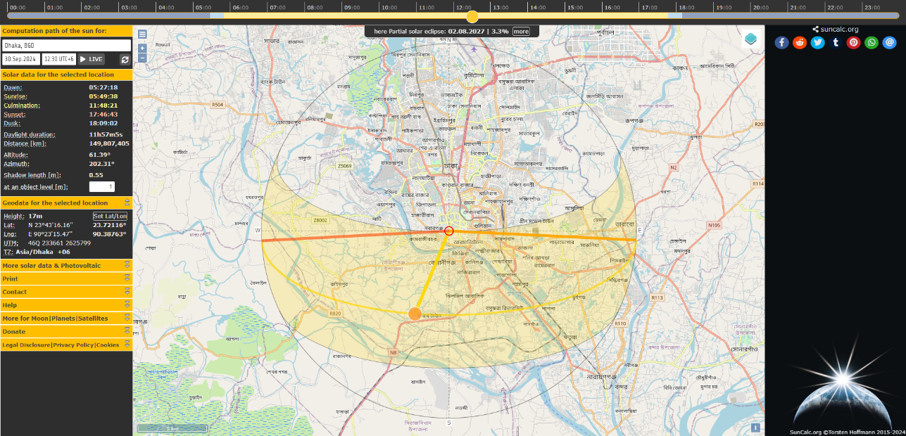
- Feedback Mechanism: A feedback mechanism can be incorporated to ensure accurate tracking and prevent overshoot.
Figure 1: Sun Path at Dhaka, Bangladesh

By using this basic approach, a dual-axis solar tracker can be constructed without the need for a microcontroller, relying solely on LDR sensors and basic logic gates. This comprehensive methodology outlines the systematic approach employed in the design and implementation of the dual-axis solar tracking system, showcasing how the use of basic logic gates can effectively optimize solar energy collection.

System Design
Components:
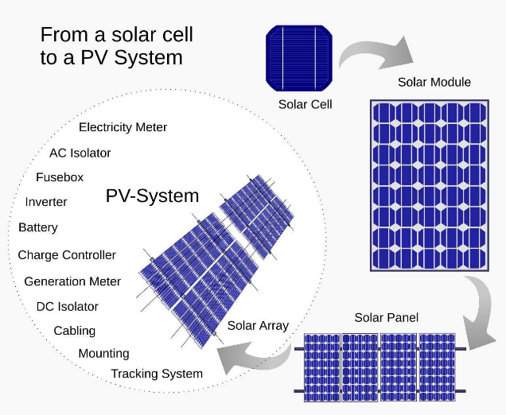
1.Solar Panel: A photovoltaic (PV) module, commonly known as a solar panel, consists of PV cells that convert sunlight into DC electricity. These panels are typically made from crystalline silicon or thin-film cells and are designed to withstand mechanical damage and moisture. Solar arrays, made up of multiple modules, supply electricity to various devices. While modules are rated for output under standard test conditions, actual performance may vary depending on installation conditions, with typical power outputs ranging from 100 to 365 watts.
Figure 2 : Solar PV Module

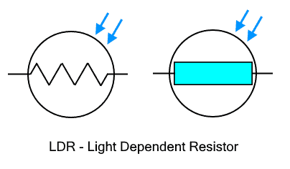
2.LDR Sensors: An LDR is defined as a component that features a resistance that varies with the sunlight intensity that falls upon it. This allows them to include in light sensing circuits.
Figure 3 : Symbol of LDR Sensor
.When the light is projected on its surface, the material conductivity decreases, and also the electrons in the valence band of the device are jumped or excited to the conduction band. These photons in the incident light should have energy greater than the band gap of the semiconductor material considered.

TYPES OF LDRs
LDRs are categorized based on the materials used in them. Intrinsic Photo resistors are made of pure semiconductor devices like silicon or germanium. When the light falls on the LDR, then the electrons get excited and the number of charge carriers increases. Extrinsic Photo Resistors are injected with impurities and these impurities produce a new energy band over the valence band. These are filled with electrons. Therefore, this decreases the band gap and a small amount of energy is needed for moving them. These are mainly implemented for applications with long wavelengths.

CHARACTERISTICS OF LDR
LDR sensor is very sensitive to light. The resistance is inversely proportional to strength of light. With the increase of illumination intensity, the resistance value of the LDR’s photo resistor decreases rapidly. When a light-dependent resistor is kept in dark, its resistance is extremely high. This resistance is known as dark resistance. It is very high and if the device is allowed to absorb light its resistance will be decreased drastically. The characteristics are shown in figure below.
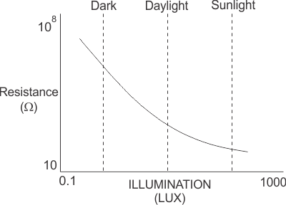
3.Logic Gates
Figure 4: Characteristics Curve of LDR Sensor
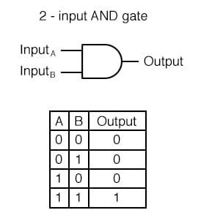
AND Gates: AND gates are fundamental digital logic gates that perform a logical AND operation on their inputs. They produce a high output (1) only when all of their inputs are high (1). If any input is low (0), the output will be low (0). Basing on input there are two inputs, three input, four input AND gate.
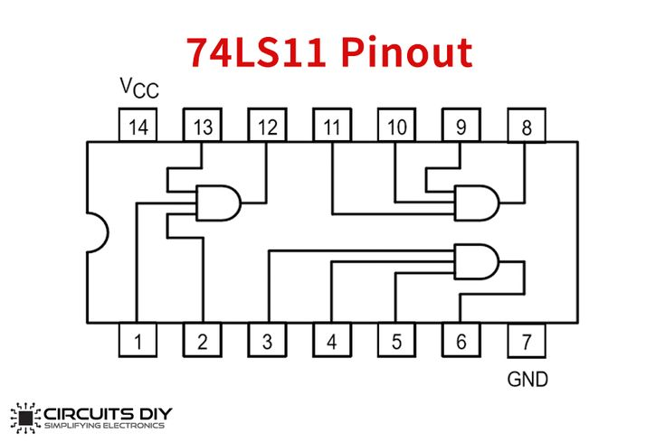
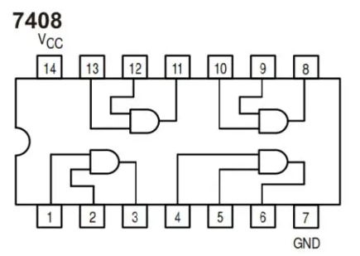
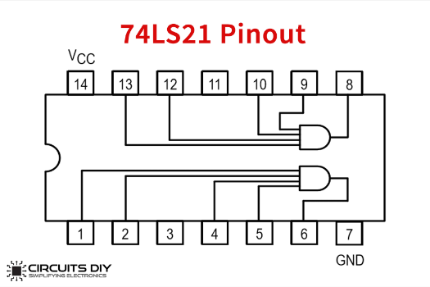
Figure 5 : 4 Input AND Gate
Figure 6 : 3 Input AND Gate
Figure 7: 2 Input AND Gate

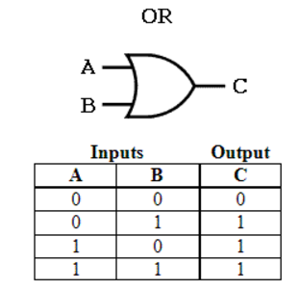
OR Gate: OR gates are fundamental digital logic gates that perform a logical OR operation on their inputs. They produce a high output (1) if at least one of their inputs is high (1). Only when all inputs are low (0) will the output be low (0). Basing on input there are two inputs, three input, four input AND gate.

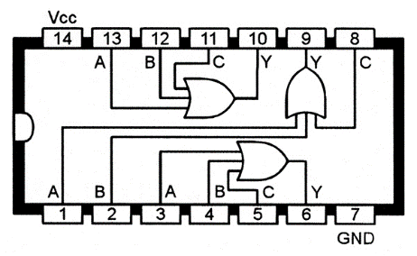
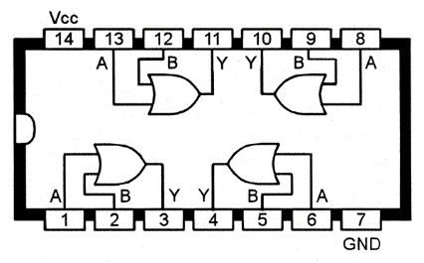
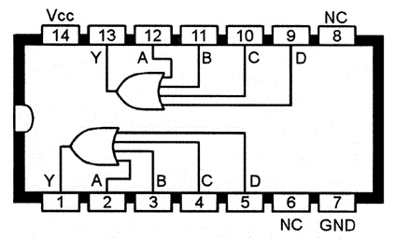

Figure 8: 2 Input OR gate
Figure 9: 4 Input OR gate
Figure 10: 3 Input OR gate

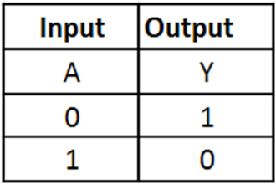
Inverter / NOT Gate: NOT gates are the simplest digital logic gates. They have a single input and a single output. They perform a logical NOT operation, inverting the input. In other words, if the input is high (1), the output will be low (0), and vice versa
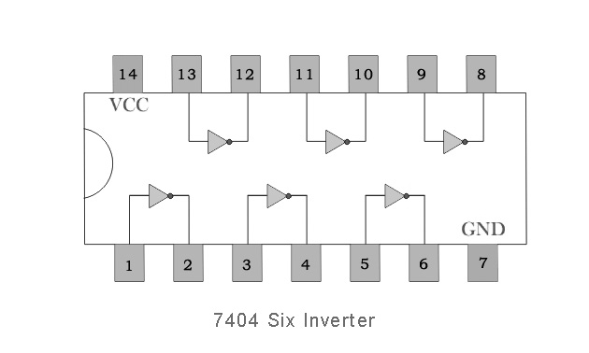
Figure 11: Hex Converter

4.L298n Motor DriverL298N Motor Driver: The L298N is a high-voltage, high-current motor driver integrated circuit (IC) designed to control the speed and direction of DC motors. It's a popular choice for robotics, automation, and other applications where precise motor control is required.

Typical Applications:
- Robotics: Controlling the movement of robotic arms, legs, and wheels.
- Automation: Driving motors in industrial automation systems.
- Model Vehicles: Controlling the speed and direction of motors in remote-controlled cars, boats, and planes.
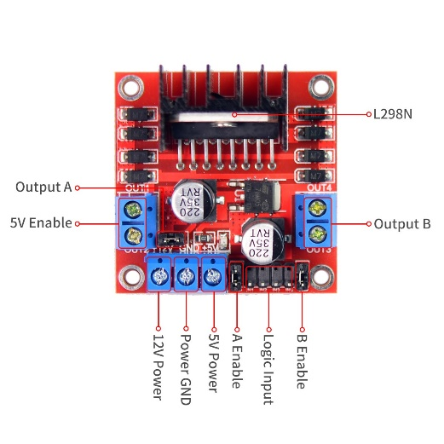
Figure 12 : L298N Motor Driver

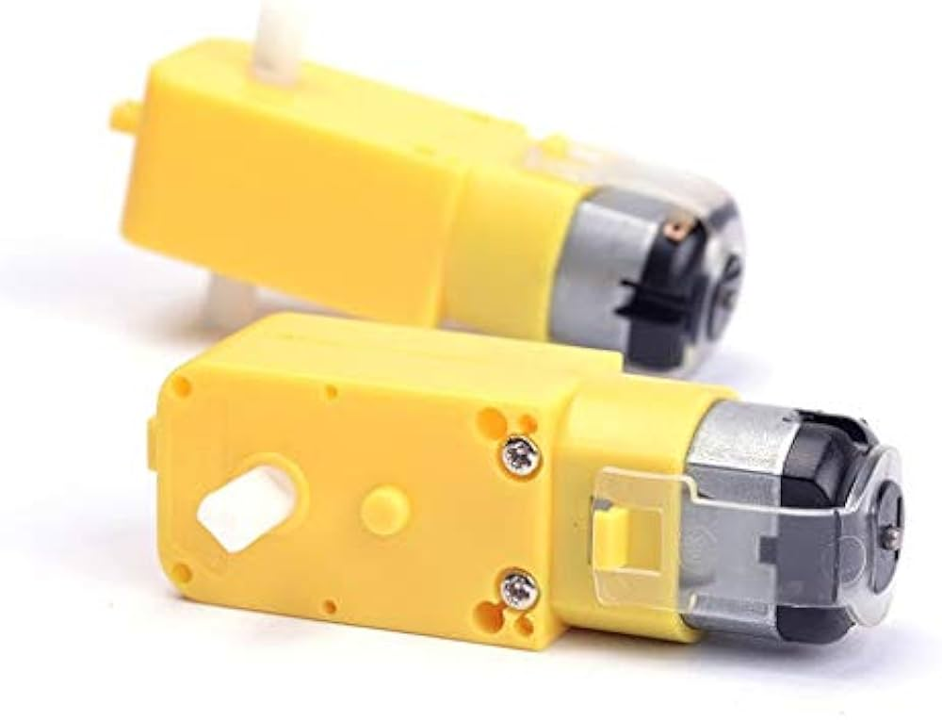
5.DC Motor: DC motors are electric motors that convert direct current (DC) electrical energy into mechanical energy. They are widely used in various applications due to their versatility, efficiency, and ease of control.
Figure 13: Basic DC Motor
Key Components:
- Stator: The stationary part of the motor, typically made of laminated iron sheets.
- Rotor: The rotating part of the motor, also known as the armature, containing windings of copper wire.
- Commutator: A segmented ring connected to the rotor windings, responsible for reversing the current direction in the rotor windings as it rotates.
- Brushes: Carbon blocks that make contact with the commutator, transferring current to the rotor windings.
- Magnets: Permanent magnets or electromagnets that create a magnetic field interacting with the rotor windings to produce torque.

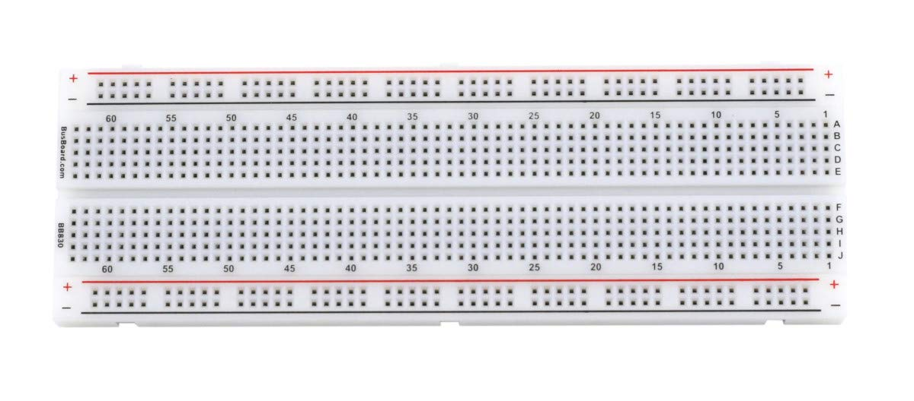
6.Breadboard: A breadboard is a solderless device for temporary prototype with electronics and test circuit designs. Most electronic components in electronic circuits can be interconnected by inserting their leads or terminals into the holes and then making connections through wires where appropriate. The breadboard has strips of metal underneath the board and connect the holes on the top of the board. The metal strips are laid out as shown below. Note that the top and bottom rows of holes are connected horizontally and split in the middle while the remaining holes are connected vertically.
Figure 14 : A Breadboard

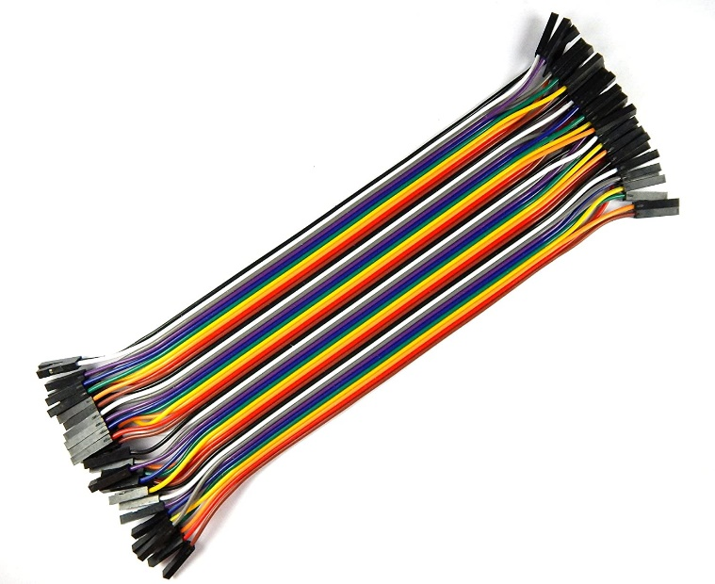
7.Jumper wire Jumper wires are simply wire that have connector pins at each end, allowing them to be used to connect two points with each other without soldering. Jumper wires are typically used with breadboards and other prototyping tools in order to make it easy to change a circuit as needed. Jumper wires typically come in three versions: male-to-male, male-to-female and female-to female. The difference between each is in the end point of the wire. Male ends have a pin protruding and can plug into things, while female ends do not and are used to plug things into. Male-to-male jumper wires are the most common and what you likely will use the most often. When connecting two ports on a breadboard, a male-to-male wire is what you’ll need.
Figure 15: Jumper Wires

Block Diagram:
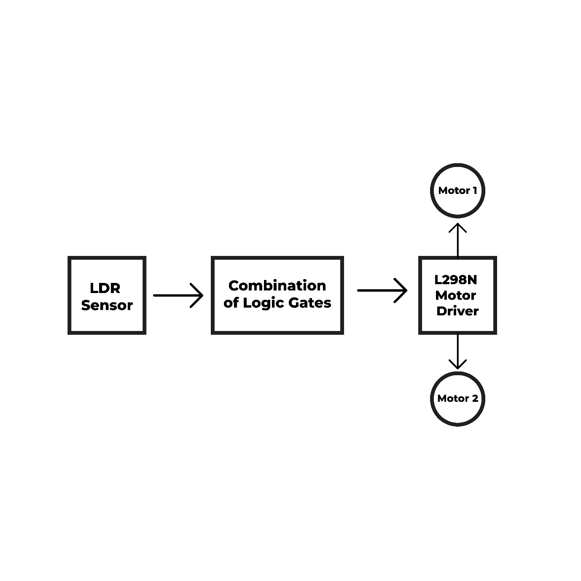
Figure 16 : Block Diagram for Dual Axis Solar Tracker

Block Diagram Description: Dual-Axis Solar Tracker
Overview: The provided block diagram illustrates the basic components and their interactions in a dual-axis solar tracker system. This system is designed to continuously adjust the orientation of solar panels to maximize sunlight exposure and energy generation.
Components:
LDR Sensor: This light-dependent resistor (LDR) is responsible for sensing the intensity of sunlight. It acts as a variable resistor, changing its resistance based on the amount of light it receives.
Combination of Logic Gates: This block represents a combination of logic gates (AND, OR, NOT, etc.) that process the input from the LDR sensor. The specific combination of logic gates would depend on the desired control algorithm for the solar tracker. This block might be used to determine the direction and magnitude of adjustment needed for solar panels.
L298N Motor Driver: This component is an integrated circuit (IC) that controls the speed and direction of DC motors. It receives control signals from the logic gates and drives the motors that adjust the solar panel's orientation.
Motor 1 and Motor 2: These represent the two motors that are responsible for adjusting the solar panel's orientation along the horizontal and vertical axes. The L298N motor driver controls the speed and direction of these motors based on the signals received from the logic gates.

Functionality:
Sunlight Sensing: The LDR sensor measures the intensity of sunlight and transmits this information to the logic gates.
Logic Gate Processing: The combination of logic gates processes the LDR sensor data to determine the required adjustment to the solar panel's orientation.
Motor Control: The L298N motor driver receives control signals from the logic gates and drives Motor 1 and Motor 2 to adjust the solar panel's position accordingly.
Solar Panel Adjustment: The movement of Motor 1 and Motor 2 causes the solar panel to rotate along the horizontal and vertical axes, ensuring that it always faces the sun directly.

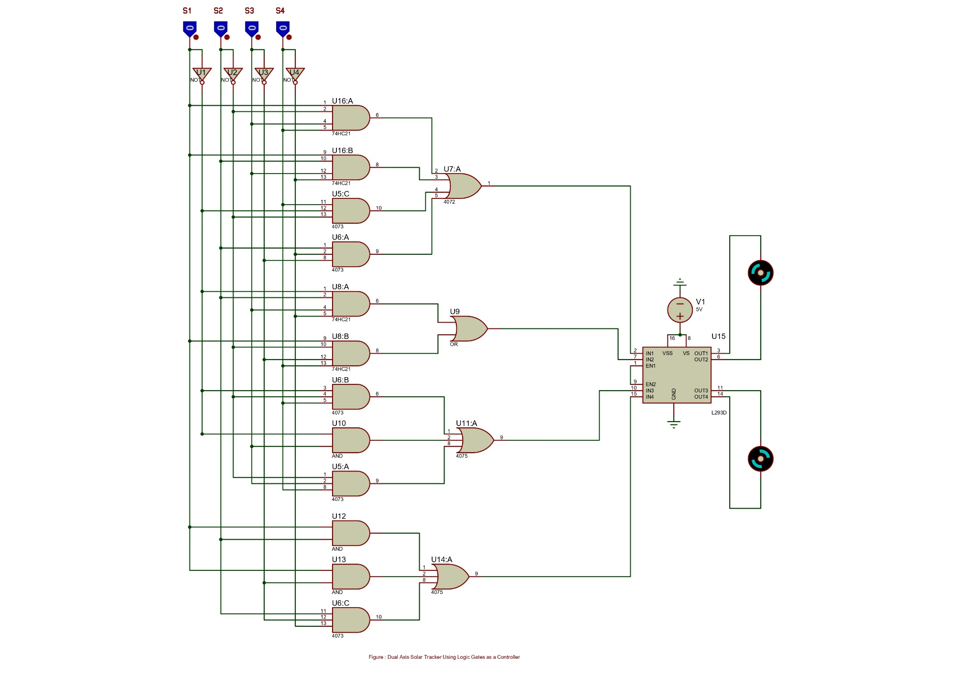
Circuit Diagram
Figure 17 : Circuit Diagram of Dual Axis Solar Tracker Using Logic Gates as a Controller

Software
Simulation: While doing this simulation it was following the table below.

Truth Table:
Logic  State | LDR Inputs |  |  |  | DC Motor 1 |  | DC Motor 2
 | S1 | S2 | S3 | S4 | CW1 | CCW1 | CW2 | CCW2
0 | 0 | 0 | 0 | 0 | 0 | 0 | 0 | 0
1 | 0 | 0 | 0 | 1 | 1 | 0 | 1 | 0
2 | 0 | 0 | 1 | 0 | 0 | 0 | 1 | 0
3 | 0 | 0 | 1 | 1 | 1 | 0 | 1 | 0
4 | 0 | 1 | 0 | 0 | 1 | 0 | 0 | 1
5 | 0 | 1 | 0 | 1 | No action needed
6 | 0 | 1 | 1 | 0 | 0 | 1 | 1 | 0
7 | 0 | 1 | 1 | 1 | 0 | 0 | 1 | 0
8 | 1 | 0 | 0 | 0 | 0 | 0 | 0 | 1
9 | 1 | 0 | 0 | 1 | 0 | 1 | 0 | 1
10 | 1 | 0 | 1 | 0 | No action needed
11 | 1 | 0 | 1 | 1 | 1 | 0 | 1 | 0
12 | 1 | 1 | 0 | 0 | 1 | 0 | 1 | 1
13 | 1 | 1 | 0 | 1 | 0 | 0 | 0 | 1
14 | 1 | 1 | 1 | 0 | 1 | 0 | 0 | 1
15 | 1 | 1 | 1 | 1 | No action needed

Simplification of LOGIC Table

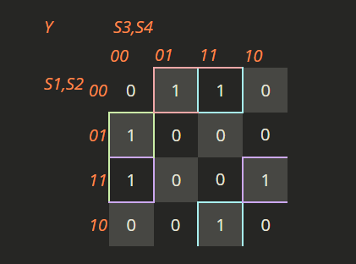
For DC Motor 1 (CW) :

Y(S1, S2, S3, S4) = S1'S2'S4 + S2S3'S4' + S2'S3S4 + S1S2S4'

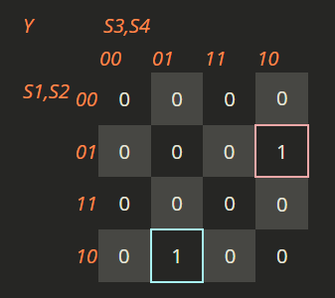
For DC Motor 1 (CCW) :

Y(S1, S2, S3, S4) = S1'S2S3S4' + S1S2'S3'S4

For DC Motor 2 (CW) :
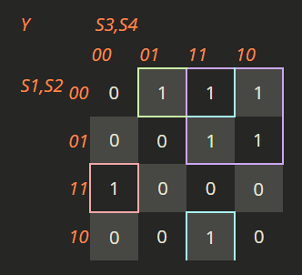
Y(S1, S2, S3, S4) = S1'S2'S4 + S1'S3 + S2'S3S4 + S1S2S3'S4'

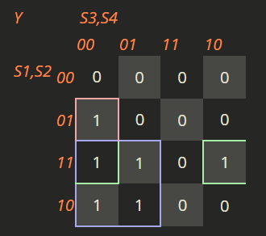
For DC Motor 2 (CCW) :

Y(S1, S2, S3, S4) = S2S3'S4' + S1S3' + S1S2S4'

The simplification of the logic expressions for the DC motor control system demonstrates the effectiveness of Boolean algebra in optimizing control logic for dual-axis solar tracking systems. Through systematic analysis and manipulation of the provided logic equations, we have derived more compact expressions that retain the original functionality while reducing complexity.
For DC Motor 1, both clockwise (CW) and counterclockwise (CCW) operations were distilled into simpler forms, maintaining necessary conditions for movement while eliminating redundancies. Similarly, the logic expressions for DC Motor 2 were streamlined, revealing critical operational states without unnecessary complexity.
This simplification not only aids in enhancing the clarity of the control logic but also contributes to the overall efficiency of the system by reducing the number of required gates and components in the circuit. By optimizing the logic, the design becomes more cost-effective and easier to implement, thus improving the practicality of solar tracking systems.

Quartus II
Quartus II is a comprehensive development software used for designing and programming digital circuits, particularly those that involve Field Programmable Gate Arrays (FPGAs) and Complex Programmable Logic Devices (CPLDs). Here are several reasons why Quartus II is widely used:

Verilog Code
module solar(
input wire S1, // Input signal S1
input wire S2, // Input signal S2
input wire S3, // Input signal S3
input wire S4, // Input signal S4

output wire DC_Motor1_CW, // Output for DC Motor 1 (Clockwise)
output wire DC_Motor1_CCW, // Output for DC Motor 1 (Counter-Clockwise)
output wire DC_Motor2_CW, // Output for DC Motor 2 (Clockwise)
output wire DC_Motor2_CCW // Output for DC Motor 2 (Counter-Clockwise)
);

// Logic for DC Motor 1 Clockwise (CW)
// The output is high (1) when any of the following conditions are met:
// 1. S1 is low, S2 is low, and S4 is high
// 2. S2 is high, S3 is low, and S4 is low
// 3. S2 is high, S3 is high, and S4 is high
// 4. S1 is high, S2 is high, and S4 is low
assign DC_Motor1_CW = (~S1 & ~S2 & S4) | (S2 & ~S3 & ~S4) | (S2 & S3 & S4) | (S1 & S2 & ~S4);

// Logic for DC Motor 1 Counter-Clockwise (CCW)
// The output is high (1) when any of the following conditions are met:
// 1. S1 is low, S2 is low, S3 is high, and S4 is low
// 2. S1 is low, S2 is high, S3 is low, and S4 is low
assign DC_Motor1_CCW = (~S1 & ~S2 & S3 & ~S4) | (~S1 & S2 & ~S3 & ~S4);

// Logic for DC Motor 2 Clockwise (CW)
// The output is high (1) when any of the following conditions are met:
// 1. S1 is low, S2 is low, and S4 is high
// 2. S1 is low, and S3 is high
// 3. S2 is low, S3 is high, and S4 is high
// 4. S1 is high, S2 is high, S3 is low, and S4 is low
assign DC_Motor2_CW = (~S1 & ~S2 & S4) | (~S1 & S3) | (~S2 & S3 & S4) | (S1 & S2 & ~S3 & ~S4);

// Logic for DC Motor 2 Counter-Clockwise (CCW)
// The output is high (1) when any of the following conditions are met:
// 1. S2 is high, S3 is low, and S4 is low
// 2. S1 is low, and S3 is high
// 3. S1 is high, S2 is high, and S4 is low
assign DC_Motor2_CCW = (S2 & ~S3 & ~S4) | (~S1 & S3) | (S1 & S2 & ~S4);

endmodule
Results and Discussion
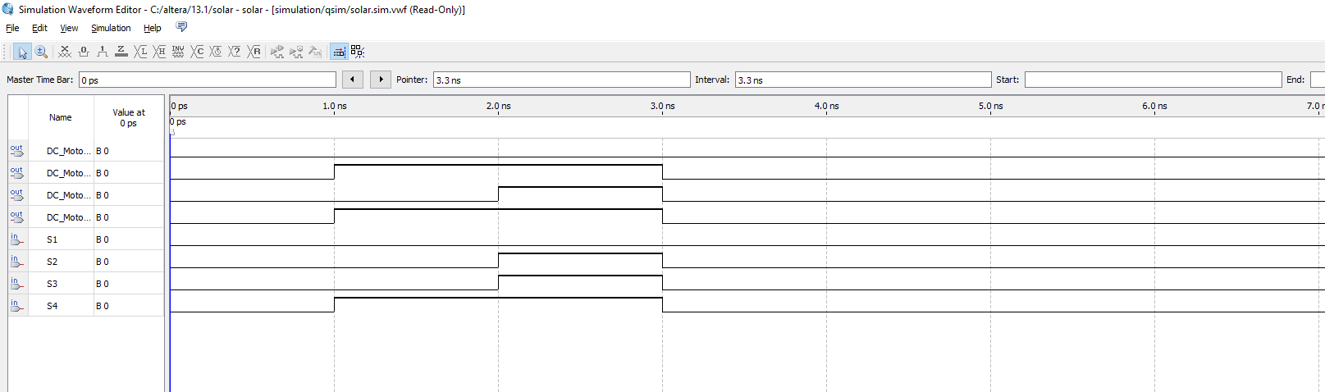
Figure 18: Verilog HDL Output
The Verilog code provided is designed to control two DC motors (Motor 1 and Motor 2) based on input from four Light Dependent Resistors (LDRs) labeled S1, S2, S3, and S4. The truth table and logic simplification equations help define the conditions under which each motor will rotate clockwise (CW) or counter-clockwise (CCW).

Overview of the Logic
- Inputs (S1, S2, S3, S4): These represent the LDR inputs, which likely detect light or darkness in a solar tracker system. The combination of these inputs determines how the motors should move.
- Outputs:
  - DC_Motor1_CW: Controls DC Motor 1 in a clockwise direction.
  - DC_Motor1_CCW: Controls DC Motor 1 in a counter-clockwise direction.
  - DC_Motor2_CW: Controls DC Motor 2 in a clockwise direction.
  - DC_Motor2_CCW: Controls DC Motor 2 in a counter-clockwise direction.

Breakdown of Logic for Each Motor:

1. DC Motor 1 Clockwise (CW) Logic:
- The equation for DC_Motor1_CW:
DC_Motor1_CW = (~S1 & ~S2 & S4) | (S2 & ~S3 & ~S4) | (S2 & S3 & S4) | (S1 & S2 & ~S4);
- This logic corresponds to the conditions under which DC Motor 1 rotates clockwise:
  - When S1 is low (0), S2 is low (0), and S4 is high (1), or
  - When S2 is high (1), S3 is low (0), and S4 is low (0), or
  - When S2 is high (1), S3 is high (1), and S4 is high (1), or
  - When S1 is high (1), S2 is high (1), and S4 is low (0).

2. DC Motor 1 Counter-Clockwise (CCW) Logic:
- The equation for DC_Motor1_CCW:
DC_Motor1_CCW = (~S1 & ~S2 & S3 & ~S4) | (~S1 & S2 & ~S3 & ~S4);
- This logic corresponds to the conditions under which DC Motor 1 rotates counter-clockwise:
  - When S1 is low (0), S2 is low (0), S3 is high (1), and S4 is low (0), or
  - When S1 is low (0), S2 is high (1), S3 is low (0), and S4 is low (0).

3. DC Motor 2 Clockwise (CW) Logic:
- The equation for DC_Motor2_CW:
DC_Motor2_CW = (~S1 & ~S2 & S4) | (~S1 & S3) | (~S2 & S3 & S4) | (S1 & S2 & ~S3 & ~S4);
- This logic corresponds to the conditions under which DC Motor 2 rotates clockwise:
  - When S1 is low (0), S2 is low (0), and S4 is high (1), or
  - When S1 is low (0) and S3 is high (1), or
  - When S2 is low (0), S3 is high (1), and S4 is high (1), or
  - When S1 is high (1), S2 is high (1), S3 is low (0), and S4 is low (0).

4. DC Motor 2 Counter-Clockwise (CCW) Logic:
- The equation for DC_Motor2_CCW:
DC_Motor2_CCW = (S2 & ~S3 & ~S4) | (~S1 & S3) | (S1 & S2 & ~S4);
- This logic corresponds to the conditions under which DC Motor 2 rotates counter-clockwise:
  - When S2 is high (1), S3 is low (0), and S4 is low (0), or
  - When S1 is low (0) and S3 is high (1), or
  - When S1 is high (1), S2 is high (1), and S4 is low (0).

How This Relates to the Truth Table:
The provided truth table shows 16 possible combinations of the LDR inputs (S1, S2, S3, S4). For each combination, the truth table specifies which motors should be active in CW or CCW directions.
For example:
- Logic State 1 (S1=0, S2=0, S3=0, S4=1):
  - According to the truth table:
    - DC Motor 1 should rotate clockwise (CW1=1), and
    - DC Motor 2 should rotate clockwise (CW2=1).
  - This aligns with the logic equation for DC_Motor1_CW, where:
    - (~S1 & ~S2 & S4) is true (since S1=0, S2=0, and S4=1).
  - Similarly, the equation for DC_Motor2_CW includes the same condition (~S1 & ~S2 & S4), which is also true.
- Logic State 5 (S1=0, S2=1, S3=0, S4=1):
  - The truth table indicates no action is needed, so both motors should remain inactive.
  - This is reflected in the logic equations since no combination of inputs in the equations evaluates to true for this state.

Advantages and Limitations

Advantages of Using Basic Logic Gates in Dual-Axis Solar Trackers
- Cost-Effectiveness:
  - Reduced Component Count: Basic logic gates allow for the design of simpler control circuits, reducing the number of components needed. This can lower the overall system cost compared to more complex control systems that require additional sensors and circuitry.
- Simplified Design:
  - Ease of Implementation: The use of basic logic gates simplifies the circuit design, making it more straightforward to understand, implement, and troubleshoot. This can be particularly beneficial for smaller projects or in educational settings where simplicity is key.
- Increased Reliability:
  - Fewer Points of Failure: With a simpler circuit design based on basic logic gates, there are fewer components that could fail. This enhances the overall reliability of the tracking system, leading to reduced maintenance needs.
- Faster Response Times:
  - Real-Time Adjustments: Logic gates can process inputs quickly, allowing for immediate adjustments to the solar panel's position. This real-time capability ensures that the panels maintain optimal alignment with the sun throughout the day.
- Flexibility:
  - Modular Design: Basic logic gates can be easily combined or modified to create different control algorithms. This flexibility allows for easier upgrades and adaptations as technology evolves or project requirements change.
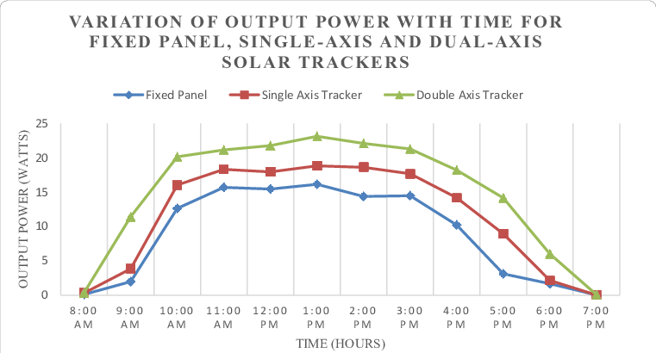
Comparison Graph:
Figure 19: Graphical representation of Output Power over the same time period for the Fixed Panel, the Single Axis Tracker, and the Dual Axis Tracking System.

Limitations of Using Basic Logic Gates in Dual-Axis Solar Trackers
- Limited Functionality:
  - Basic Operations Only: While logic gates are effective for simple control tasks, they may lack the capability to perform more complex operations needed for advanced tracking algorithms, potentially limiting system performance.
- Scalability Issues:
  - Complex Systems Require More Gates: For larger or more complex solar tracking systems, the sheer number of logic gates needed can lead to increased complexity in wiring and design, offsetting some of the simplicity benefits.
- Lack of Advanced Features:
  - No Built-in Optimization: Basic logic gates do not include advanced features like adaptive control or learning algorithms, which might be necessary for optimizing performance in variable environmental conditions.
- Increased Circuit Size:
  - Space Constraints: While basic logic gates simplify the design, a large number of gates may lead to a bulkier circuit, which can be an issue in space-constrained installations.
- Potential for Signal Interference:
  - Noise Sensitivity: Basic logic gates can be sensitive to noise, which may lead to incorrect switching or tracking inaccuracies if not properly managed.

Using basic logic gates in dual-axis solar trackers provides several advantages, such as cost savings, design simplicity, and improved reliability. However, it also presents certain limitations, particularly concerning functionality and scalability. Balancing these pros and cons is crucial when designing and implementing an effective solar tracking system, ensuring that the system meets performance requirements while remaining cost-effective and maintainable.

Real-Life Implications of Dual-Axis Solar Trackers

1. Increased Energy Output
- Efficiency Boost: Dual-axis solar trackers can improve solar panel efficiency by 25-40% compared to fixed solar panels. By continuously adjusting the panel's orientation to follow the sun throughout the day and year, more sunlight is captured.
- Optimal Sun Exposure: As the sun's position changes hourly and seasonally, dual-axis trackers ensure the panels are always positioned at the best angle for maximum energy absorption. This is especially beneficial in locations with significant seasonal variations in the sun's trajectory.

2. Enhanced Performance in Various Climates
- High Latitude Regions: In areas far from the equator, the sun's angle varies greatly with seasons. Dual-axis trackers can adjust accordingly, ensuring maximum performance even during winter months when the sun is lower in the sky.
- Cloudy and Partially Sunny Conditions: In regions with intermittent sunshine, dual-axis trackers can better capture sunlight as they adjust dynamically throughout the day to find the best angle to maximize energy collection.

3. Better ROI for Solar Farms
- Maximizing Land Usage: For large-scale solar farms, especially where land is limited or costly, using dual-axis trackers can significantly increase the energy output per square meter. This enhances the return on investment (ROI) by producing more electricity per installation.
- Long-Term Cost Efficiency: Although dual-axis trackers come with higher initial costs due to their mechanical complexity, the increased energy production can lead to higher profits in the long term, offsetting the upfront expenses.

4. Application in Off-Grid Systems
- More Reliable Power Supply: In off-grid solar systems, such as those used in rural areas or for remote applications (e.g., telecommunication towers, water pumps), maximizing energy production is critical. Dual-axis trackers ensure that these systems can generate as much power as possible, reducing the need for backup power sources like diesel generators.
- Reducing Energy Storage Needs: Since dual-axis systems produce more energy throughout the day, the need for extensive battery storage systems is reduced. This can lower the overall cost of the off-grid system.

5. Supporting Smart Grid and Renewable Energy Goals
- Integration into Smart Grids: As the global energy grid evolves into a smart grid, solar energy with dual-axis tracking systems can play a crucial role. These trackers can help stabilize energy production, feeding a more consistent amount of energy into the grid throughout the day.
- Meeting Renewable Energy Targets: Many countries have set ambitious renewable energy targets. Dual-axis solar trackers can help meet these goals faster by increasing the solar output of installed capacity. This is particularly important in countries with limited space for large solar farms.

6. Higher Initial Costs and Maintenance
- Increased Installation Costs: Dual-axis trackers are more expensive to install than fixed panels or single-axis trackers due to their mechanical components and more complex structures.
- Maintenance Requirements: The mechanical systems of dual-axis trackers are more prone to wear and tear due to continuous movement, leading to higher maintenance costs over time. Regular servicing is needed to ensure smooth operation, which can be a disadvantage in remote areas with limited access to technicians.

7. Environmental Impact
- Optimized Use of Renewable Energy: By maximizing energy generation, dual-axis solar trackers help reduce the reliance on fossil fuels, thus reducing greenhouse gas emissions and contributing to a more sustainable energy system.
- Land Use Efficiency: Dual-axis trackers help minimize the land footprint for solar installations, as they extract more energy from the same area compared to fixed or single-axis systems. This can reduce the environmental impact of large solar farms and make them more viable in space-constrained regions.

Future Scope
Commercially, dual axis solar tracking is still rare even in countries wherever a major part of electricity is being produced by solar energy as they claim that single axis tracking is doing the work. However dual axis tracking will noticeably increase the potency. For our project work we’ve implemented this procedure in basic logic gate. Cost effectiveness and proposed system potency may be discovered on a business level. We used LDR for this proposed model but LDR is not a good choice as a sensor as it affected by dust. So in future, we can also use the more efficient sensor. A reliable structure is very expensive compared to solar panel cost; therefore, adding an additional panel to the system instead of spending on tracking structure is much more cost effective.

Conclusion:
The dual-axis solar tracking system demonstrates a significant advancement in aligning solar panels with the sun's trajectory, enabling enhanced energy capture in a cost-effective manner. The experimental results clearly indicate that dual-axis tracking outperforms both single-axis and fixed solar systems, resulting in a notable increase in energy generation. Our findings reveal that implementing dual-axis tracking can boost energy output by approximately 40% compared to fixed arrays, showcasing its effectiveness in optimizing solar energy utilization.
Furthermore, the use of basic logic gates in the control system simplifies the design while maintaining high performance. By leveraging simple logic gates, the proposed tracking system not only reduces complexity and cost but also enhances reliability. As we continue to refine our design and explore more advanced systems, we are optimistic that the efficiency gains from dual-axis tracking can be further improved. This positions dual-axis tracking as a compelling solution for maximizing solar energy production, paving the way for more sustainable and efficient solar energy systems in the future.
References:

- Daily Generation Data sheet, Bangladesh Power Development Board (BPDB),available at <> Last accessed on 06 June, 2017 at 12:30 pm.
- Cheema, Sukhraj Singh. “Simulation studies on dual axis solar photovoltaic panel tracking system.” PhD diss., Thapar University Patiala,2012
- https://www.researchgate.net/publication/330625514_Design_and_Performance_Evaluation_of_a_Dual-Axis_Solar_Tracking_System_for_Rural_Applications/figures?lo=1&utm_source=google&utm_medium=organic
- N. Othman, “Performance Analysis of Dual-axis solar tracking system”, IEEE Conf., 2013
- Hossein Mousazadeh et Al.,[ (2011), Journal of Solar Energy Engineering,Vol.133 ]
- https://www.suncalc.org/#/23.7212,90.3876,12/2024.09.30/22:46/1/0
- https://www.charlie-coleman.com/experiments/kmap/

